Love the lawn
Lawns offer us several benefits. Beside preventing erosion, filtering the air, muffling noise, weed control, insect control, varmint and snake control (that's an important one for some of you), lawns also give us a place to entertain family, friends and pets. Yards define our personal space. Maintaining our yards gives us a sense of accomplishment, pride and is an excellent form of exercise. It also contributes to the feeling of a community; everyone in the neighborhood knows "That" yard, good or bad. We talk about our yards, other yards and the yard we wished we had. Yard maintenance in the U.S. is a huge industry, over 40 billion (that is 10 zeros and a bunch of green). You can read all about the history of lawns at http://en.wikipedia.org/wiki/Lawn and thank the inventor of the push mower while you’re at it.

Unfortunately...
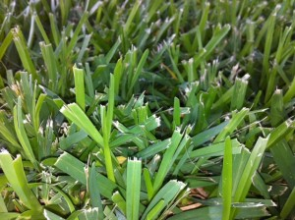
Sharpen that blade!
It seems like everyone with a truck and a mower thinks they are a lawn maintenance company (and if they have a shovel, they think they are landscapers...). Let's face facts; we want amazing results, cheap. We assume that if they own a mower and a weed eater, they must know how to use it. It looks that simple. Start it, push it. This couldn't be further from the truth. There are actually rules for mowing a yard. The picture above, shows my grass 48 hours after it was mowed. Every leaf shows damage from a dull blade. Instead of a nice smooth cut, the blades are torn. The damaged tips turn white(ish) and gives the lawn a dull look from a distance.

The rules are:
- Keep your blade sharp. True professional mow teams sharpen their blades EVERY day. Eight hours of mowing = sharpening. If it takes you an hour to mow your lawn, get the blade sharpened every 8 weeks. Do the math for your own yard.
- If your blade is nicked or damaged, replace it. Damaged blades don't cut evenly and damage the grass and can leaves a big, slow healing wound for disease to enter.
- Mow St. Augustine as high as the mower will go (3").
- Avoid mowing during the heat of the day; it's bad for the grass and uncomfortable for you.
- Never mow wet grass, wait until the dew dries.
- Trim the edges first. Use a string trimmer or an edger. The picture to the below shows damage where a string trimmer was used (the string horizontal to the ground). It cut the grass too short, killing it in spots. It should have been turned so the string was vertical, to cut grass that was growing on top the stone only. Trying to edge with a mower is like trying to ice a cupcakes with a yard stick, you might get the job done, but it aint gonna' be pretty. After you're done mowing, use the weed eater again for a final touch up.
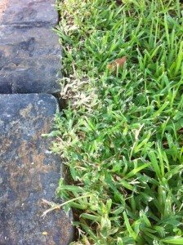
- Mow in straight lines, never in spirals.
- Overlap your rows by 50%. I know it sounds like more work, but it is easier on the mower and easier to push. Your lawn will be smoother and you won't miss spots or leave long streaks.
- Change direction of your lines every 2 or 3 cuts. This allows the grass to grow more naturally and evenly. It also prevents scalping the same spot repeatedly.
- Walk at an even pace. If you are too slow, the mower can clog, too fast and every blade will not get cut.
- Make turns OFF the grass if possible or lift front end (by pushing the handle down until front comes up) and do a 3 point turn.
- Mow around the border last. You will actually mow it twice, but it gives a nice finish and creates a picture frame for the lawn.
- I know this one won't apply to most of us in Houston, but here it is anyway. Mow across hills and berms, not up and down. Fresh cut grass can be slippery and loosing a body part just ain' t a cool look. If you are using a riding mower, you can go up and down.
- Never pull a push mower, it's dangerous.
- Wear eye protection. Objects can leave the shoot at 200 mph...eye patches are for pirates.
- Keep children and pets out of the yard while mowing. On second though, a pirate poodle might make you money on YouTube.
- Remove hoses, toys, branches and doggy doo (flying poo!!! EEEEWWWWWWW).
- Flag sprinkler heads...or call our buddy Jim Rockwell (Allied Sprinkler) at 281-463-6663 for repairs.
- Last but not least, follow manufacturer’s directions on cleaning mower and preventing rust.

