HOME FRUIT PRODUCTION - STONE FRUIT
Peaches, Nectarines, Plums
Larry A. Stein, Calvin G. Lyons and John Lipe
Extension Horticulturists
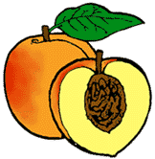
Fruit trees are widely adapted in Texas. However, success in growing fruit trees and in producing quality fruit doesn't just happen. Careful attention must be given to basic management practices including site selection, variety selection, weed control, water and pest management.
Soil and Site Requirements
Good soil moisture drainage is essential for growing healthy, productive trees. Soils with standing water or ones that remain saturated for even a day or two following a heavy rain are unsuitable for fruit trees. If this describes your soil, you can still grow fruit by planting trees in well-drained, raised beds. Prepare beds by bringing in or scraping up topsoil into a 6- to 12-inch-high mound at least 8 to 10 feet across. High organic potting soil mixes are less desirable because they encourage continual fall growth and make young trees more vulnerable to winter freeze injury. A raised bed can be framed with railroad ties or edging timbers for a more attractive appearance.
A soil fertility test before planting helps avoid undesirable sites, and minerals such as phosphorus and potassium can be added before planting where needed. Information on soil testing is available from your local county Extension office.
Plentiful sunlight is a key to maximizing fruit production. Choose an area that is sunny most or all of the day. Early morning sunshine is particularly important to dry dew from the plants; thereby, reducing the incidence of diseases. If the planting site does not get sufficient sun, expect reduced performance from the trees.

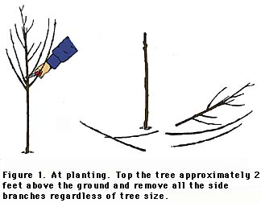
Purchasing Trees
Purchase trees from a reliable nursery source. Bargain plants may not be healthy or may not be a variety adapted to your area. Ideally, purchase 3- to 4-foot trees with good root systems free of apparent disease problems. A smaller tree with a good root system is more desirable than a larger tree with a poor root system. Specify that you want trees that are budded onto Nemaguard rootstock to prevent rootknot nematode damage. Most fruit trees are sold "bare root." Purchase and plant bare root trees while fully dormant, generally in December through February for most of Texas.
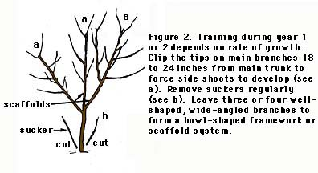
Soil Preparation and Planting
Thoroughly prepare the soil by deeply cultivating, either by hand or with a rototiller before planting. At this time also make any recommended adjustments to the soil.
When the fruit trees arrive from the nursery, open the bundles immediately to inspect for damage and check general condition of the trees. Do not accept trees if roots appear to have dried out. This is also true for trees purchased from your local nursery or garden center. "Heel in" the trees if you are not ready to plant them. Simply dig a shallow trench in which tree roots or a bundle of trees can be covered with moist soil to protect them until planting.
Plant in the winter, preferably before March 1, to allow for root development before spring growth. Before planting, soak the roots for no more than 1 hour to ensure they are not under any moisture stress.
Dig the planting hole just large enough for the tree's root system to be spread in a natural position. Avoid digging a hole deeper than the root system as loose soil beneath the roots usually causes trees to sink too deeply. Larger holes filled with topsoil are of no benefit unless the soil at the planting site is extremely poor (rocky, calcareous, etc.). In this case, use raised beds.
Stone fruit trees will develop at least a 15-foot diameter limbspread at maturity. Plant them at least 20 feet apart to avoid excessive competition. Set plants at approximately the same depth that they grew in the nursery. Using the soil taken out of the hole, firm it around the roots and do not add fertilizer to the hole. Water the trees thoroughly soon after they are set; be sure that air pockets in the hole are filled and that the soil is at the proper level on the base of the tree after watering.
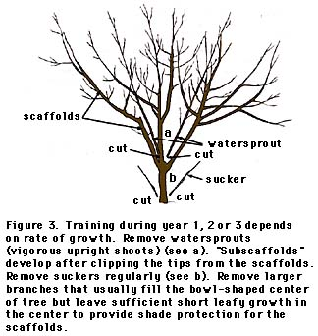
Pruning and Training
Pruning a young tree controls its shape by developing a strong, well-balanced framework of scaffold branches. The open center pruning system is best suited for stone fruit trees. Since most fruit trees bear fruit on wood that grew the previous year, this wood is regrown from year to year. New growth needs full light or it will shade out and die with all the production occurring on the outer perimeter of the tree. The open center system outlined in figures 1-6 maximizes light penetration to all parts of the tree, resulting in fruit production over the entire tree.
Light pruning can be done any time of the year. However, perform major pruning only during the dormant season or late winter just before budbreak.
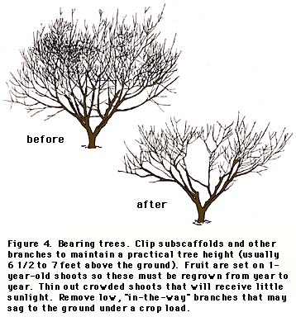
Irrigation
Water is essential for producing large fruit and maintaining healthy trees. Whether trees are watered by drip irrigation, sprinklers, the garden hose or rainfall makes little difference as long as the trees receive sufficient water. Normally trees need water at least every 3 weeks. In summer heat, provide a deep soaking irrigation at least weekly to maintain healthy trees. Overwatering can damage or drown trees. Sticky clay soils are especially vulnerable to water saturation and should be allowed to dry for a few days between each watering.
Weed Control
Eliminating weed competition around young trees is critical for survival and rapid growth. Heavy weed or grass competition results in severe nitrogen deficiency (yellow foliage with red spots); trees will produce little or no growth and often may die. Ideally, keep the soil surface weed-free in an area at least as wide as the limb spread of the tree.
The safest way to do this is with a hoe. Chemicals that will do a good job are available, but they are hazardous if used carelessly. Do not attempt chemical weed control unless all aspects of safety and sprayer calibration are well understood.

Fertilization
Fruit trees can be fertilized the first year after they leaf out in the spring. Place the fertilizer at and slightly beyond the canopy edge of the tree but never against the trunk. General recommendations for regularly watered trees are included in the following table.
 | March | April | May | June | July
Year 1 |  | 1 cup¹ balanced² | 1 cup | 1 cup | 1 cup
Year 2 | 2 cups balanced | 2cups21-0-0 | 2 cups | 2 cups | 2 cups
¹One cup of granular fertilizer is equivalent to approximately 1/2 lb.
²Apply balanced fertilizer according to soil test recommendations, or use a common mix such as 6-2-4. **
Bearing trees
February--2 cups balanced fertilizer per inch of trunk diameter
May--2 to 6 cups 6-2-4 ** per tree depending on vigor of shoot growth
August--no fertilizer if trees are making vigorous growth; 1 1/2 cups 6-2-4 ** per tree if there is no new growth but healthy leaves; 3 cups 6-2-4 ** per tree if there is no new growth and leaves are yellow.
Note: If your soil pH is above 7.5, do not apply phosphorus fertilizer.
Thinning
Fruit trees grown under favorable conditions set more fruit than can be properly developed. Removing excess fruit is necessary to ensure satisfactory development of the remaining fruit and to prevent limb breakage and shortened tree life from overcropping. Remove the fruit by hand approximately 4 weeks after bloom. Space fruit about one every 6 to 8 inches on a branch.
Disease and Insect Control
The best quality fruit is produced when diseases and insects are controlled. Unless an efficient spray program is maintained, it is not advisable to plant stone fruit trees. The most serious diseases are brown rot, scab and leaf curl.
Insect problems include scale, plum curculio, catfacing insects and peach tree borer. The first line of defense is good sanitation. Remove old diseased fruit and wood as it appears on the tree. Your county Extension office has information on timing, methods and materials to control diseases and insects. Many garden centers sell home orchard fruit tree sprays containing an insecticide and fungicide. Applying one of the products according to label directions usually controls most insect and disease pests.
Varieties
The following stone fruit varieties on pages 5 and 6 are listed according to the state's zones in which they are adaptable. See the map for the location of each zone.
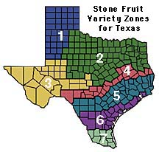
Nectarines
The nectarine is a fuzzless mutation of a peach and not a cross between a peach and a plum. Nectarines are not generally well adapted because the smooth-skinned fruit is especially vulnerable to diseases and wind-scarring. Currently the recommended variety list is small, but trials are underway by the Texas Agricultural Extension Service to evaluate new varieties.
CHARACTERISTICS OF RECOMMENDED NECTARINE VARIETIES
(ONES LISTED HAVE YELLOW COLORED FLESH)
Variety / Chill Hours | Fruit size | Stone* | Ripe date | Planting zone
Snow Queen **/ <300/ self fertile | Medium | Free | Late june | 4,5,6,7
Sunred*/200-300/ | Medium | Semi | Mid May | 4,5,6,7
*Stone (pit) adherence to flesh: cling=tight adherence; free=no adherence

Apricots
This is apricot was introduced in 2005 and is the 1st apricot we have sold. It is reported to be doing well in other mild winter areas like southern California, New Mexico and Arizona. We are going to need a few brave gardeners to give it a try and let us know how it goes.
Tropic Gold / 350/ self-fertile | Med-large | NA | May through August? | 4,5,6
Plums
Plant at least two varieties to ensure pollination of certain varieties. The recommended varieties are Japanese or Japanese-hybrid plum varieties. The large-fruited European-type plums that commonly reach the supermarkets are not as well adapted here because of greater disease susceptibility and lower production.
CHARACTERISTICS OF RECOMMENDED PLUM VARIETIES
Variety / chill hours / notes | Fruit size | Color | Ripe date | Planting zone
Beauty** / 250 /self-fertile | Large | red skin and amber flesh | Early June | 5,6, 7
Burgandy **/ <350 / self-fertile | Meduim | Purple skin and red flesh | Early July | 5,6, 7
Methley ** / 250 / self-fertile | Medium | purple skin, amber flesh | early June | 1, 2, 3, 4, 5, 6
Inca**/ 250-300 self-fertile | Medium | Green | July | 5,6, 7

Plumcots
Plumcots are a cross between a plum and an apricot. Contrary to common belief, Plumcots are self-fruitful and do not require a pollinator. The fruit is the size of a large apricot, yellow with a blushed melon red skin. The flesh is golden yellow and juicy with a plum like texture and apricot flavor. Ripens in early June and needs 300 chill hours.

Peaches
Peaches are well adapted to most parts of Texas. Because all peaches are self-fruitful, it is not necessary to plant more than one variety. One tree normally supplies more peaches than one family can consume. The later ripening varieties are of better quality.

CHARACTERISTICS OF RECOMMENDED PEACH VARIETIES
Variety /chill hours | Fruit size | Stone* | Ripe date | Planting zone
Yellow Flesh
Bonita / 250 | Med-large | Free | Late July | 5,6,7
EarliGrande / 250 | Med-large | Semi-free | Late April to late May | 5,6, 7
Early Amber / 250 | Medium | Free | Mid May | 5,6,7
FloridaPrince / 150 | Medium | Semi- free | Mid May | 5,6,7
Santa Barbara / 300 | Large | Free | Early to mid July | 5,6,7

Almonds
Almonds are eaten as a nut, but the required cultural practices and tree appearance are essentially the same as peaches. Almonds are generally poorly adapted to Texas because they bloom too early in the spring and encounter freeze problems. No varieties are highly recommended because of general failure to set crops.

The information given herein is for educational purposes only. Reference to commercial products or trade names is made with the understanding that no discrimination is intended and no endorsement by the Texas Agricultural Extension Service is implied.
Programs conducted by the Texas Agricultural Extension Service serve people of all ages, regardless of socioeconomic level, race, color, sex, religion, handicap or national origin.

Hypertext markup by Tammy Kohlleppel, Gretchen Eagle and Dan Lineberger. http://aggie-horticulture.tamu.edu/extension
** RCW Nurseries added or amended this listing. For an original copy of this information sheet, please visit http://aggie-horticulture.tamu.edu/extension/homefruit/stone/stone.html

Space for your Mumbles and Scribblin’s

